2.1 Introduction of Vector-Valued Functions

Definition: A vector-valued function or vector function, is simply a function whose domain is a subset of the real numbers and whose range is a set of vectors. If the vector function maps real numbers to n-dimensional vectors, we write: .

Note: In this class we are most interested in vector functions of the form .

Note: Very strictly speaking, it is a slight abuse to write when the domain of r is not the full set of real numbers. In particular if D is the domain of r and it is a subset of the real numbers but not equal to the real numbers, we should write . We will ignore this subtlety in this class and be aware that only means that the domain of r is a subset of real numbers.

Definition: If a vector function is of the form , then
, , and are called the component functions of .

Note: In this case we have because the real number t gets mapped to a vector .

Example 1: Find the domain of the vector function: .

Note: It is important to see that as we graph a vector-valued function in this class we are simply graphing a parametric function in 3-space. Therefore, t will act as a parameter and each vector-valued function will have an associated orientation.
Example 2: We have seen that the parametric equations for the line that passes through the points (2,-3,4) and (4,2,1) are: . How could one represent this line as a vector function?

Example 3: Sketch a graph of each of the following functions.
- for .

- for .

- for .

Example 4: Use a computer to graph the vector function:

Example 5: Match each picture below with its appropriate vector function (you are not allowed to use a computer).

Graph A:  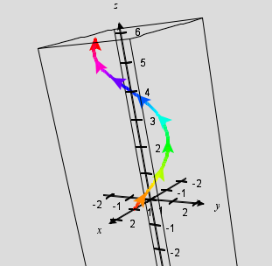 | Graph B: 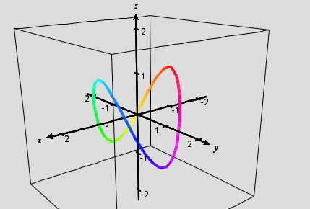

Possible functions:
1.
2.
3.
4.

